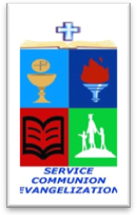
ROMAN CATHOLIC BISHOP OF NOVALICHES
EDUCATIONAL SYSTEM (RCBN-ES, Inc.)
Quirino Highway cor. P. dela Cruz St., Novaliches, Quezon City
Telephone 417-3105

POINTERS TO REVIEW IN SCIENCE 3
School Year 2017 – 2018

FOURTH QUARTER

I. Our Natural Resources
A. Conservation of Natural Resources
B. Types of Landforms and their Effects on Living Things
C. Care for and Conservation of Soil
D. Bodies of Water on Earth
E. Importance of Water
F. Keeping Sources of Water Clean

II. Types of Weather Conditions
A. Causes of Changes in the Atmosphere
B. Recording Weather Conditions

III. Natural Objects in the Sky
A. Cause of Daytime and Nighttime
B. The Stars and Moon at Night
C. Effects of the Natural Objects in Sky to Our Daily Activities
D. Good and Bad Effects of Heat and Light from the Sun
E. Protecting Oneself from the Sun’s Heat

